**AltSoftSerial Pins**

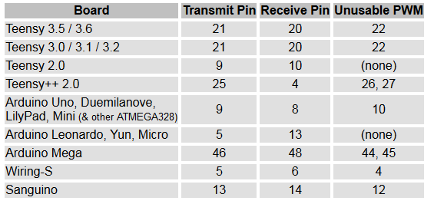

The "Unusable PWM" pins can be used normally, with digitalRead() or digitalWrite(), but their PWM function controlled by analogWrite() will not work properly, because AltSoftSerial uses the timer which controls that pin's PWM feature.